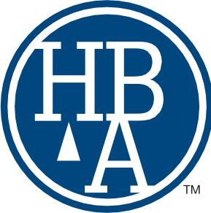
Huntsville Bar Association, Inc.
228 Holmes Avenue · 8th Floor Huntsville, Alabama 35801
256-203-4900 p · 256-203-4901 f
director@huntsvillebar.org · huntsvillebar.org

Dear Applicant:

To apply for membership in the Huntsville Bar Association, please complete the attached application. Then, mail the application, your membership dues, as well as a copy of your current State of Alabama Bar license, to Cindy Seeley, Executive Director of the Huntsville Bar Association, at 228 Holmes Avenue, 8th Floor, Huntsville, Alabama 35801. Please note that the application requires signatures of two sponsors for membership. Both sponsors must be members of the Huntsville-Madison County Bar Association in good standing.

Membership dues for new applicants are as follows:

Years Licensed in Alabama Dues Amount

1 – 5 years $ 150
6 – 10 years $ 200
11 – 50 years $ 230
50 + years Dues are waived

Once your application has been processed, you will receive an invitation to attend the Huntsville Bar monthly meeting where you will be proposed for membership, which is optional.

If you have any questions, do not hesitate to contact Cindy Seeley at (256) 203-4900 or director@huntsvillebar.org or Cathy VanValkenburgh at office@huntsvillebar.org.

Sincerely,
Eric Woods

Eric Woods
Chairman
Membership/Mentor Committee
Huntsville Bar Association

Attachment

